**Correlation between years of number of species caught**

Is there correlation between the multiple years trapping data?

Gave each site a rank of 1 up to 16 depending on the number of individuals trapped.

Pearson’s product-moment correlation test was run on the GLSA data from 2014 to 2016. There was a correlation between the years 2014 and 2015 (t = 2.255, df = 10, p-value = 0.04777, cor 0.5806018) as well as a correlation between the years 2015 and 2016 (t = 2.5758, df = 11, p-value = 0.02578, cor 0.6133791).

Pearson’s product-moment correlation test was run on the NECI data from 2014 to 2016. There no evidence of a correlation between the years 2014 and 2015 (t = 0.33442, df = 10, p-value = 0.745, cor 0.1051661) as well as no evidence of a correlation between the years 2015 and 2016 (t = 1.4194, df = 11, p-value = 0.1835, cor 0.3934447).

Pearson’s product-moment correlation test was run on the NEFU data from 2014 to 2016. There was a correlation between the years 2014 and 2015 (t = 6.4051, df = 10, p-value = 7.782e-05, cor 0.8966698) as well as a correlation between the years 2015 and 2016 (p t = 6.7881, df = 11, p-value = 3.001e-05, cor 0.8984884).

**Conduct a NMDS to identify the Loadings that most impact PC1**

**OPENNESS**

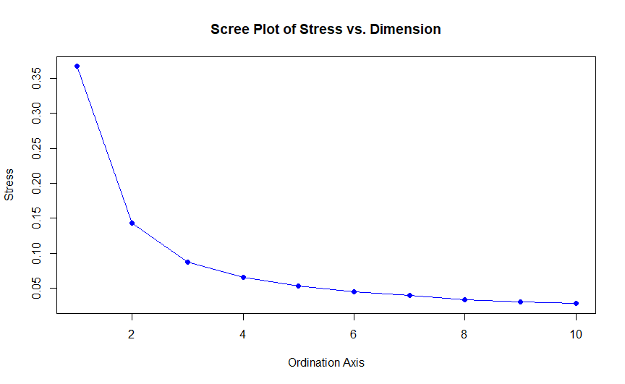

Figure . Openness Scree Plot

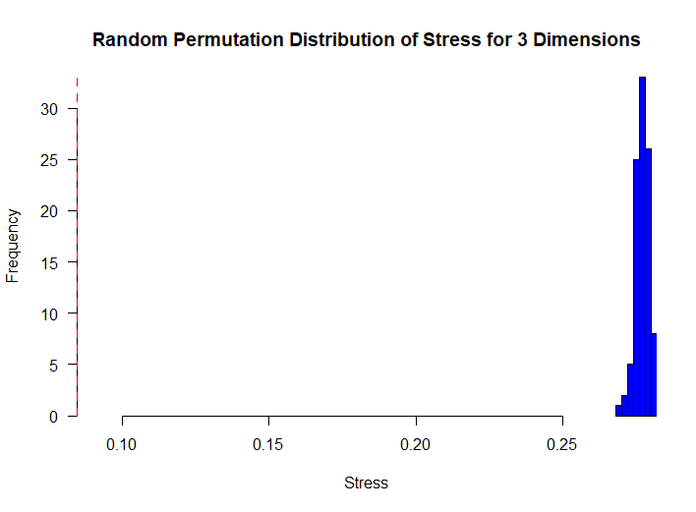 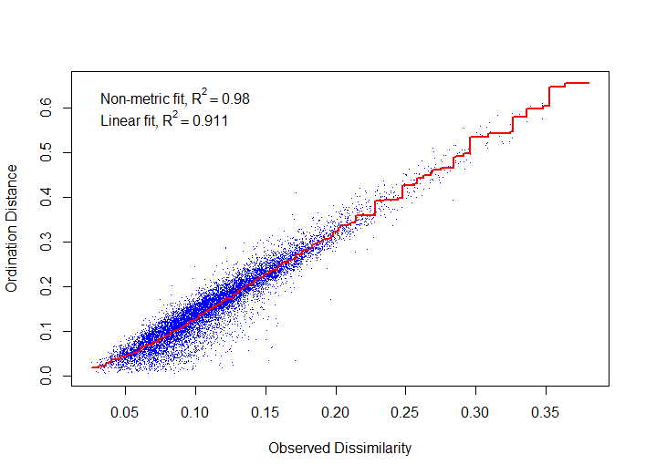

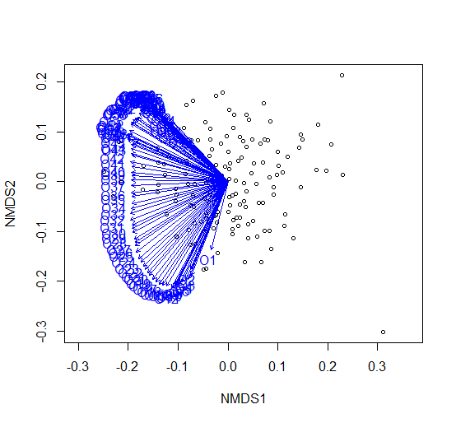 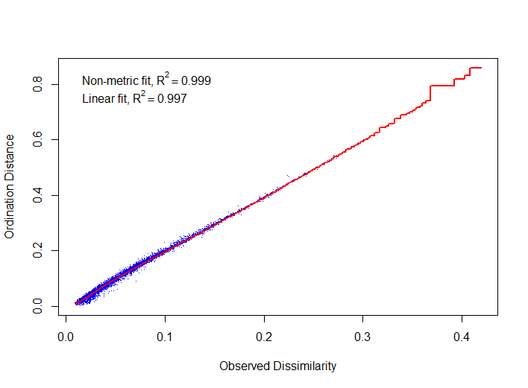

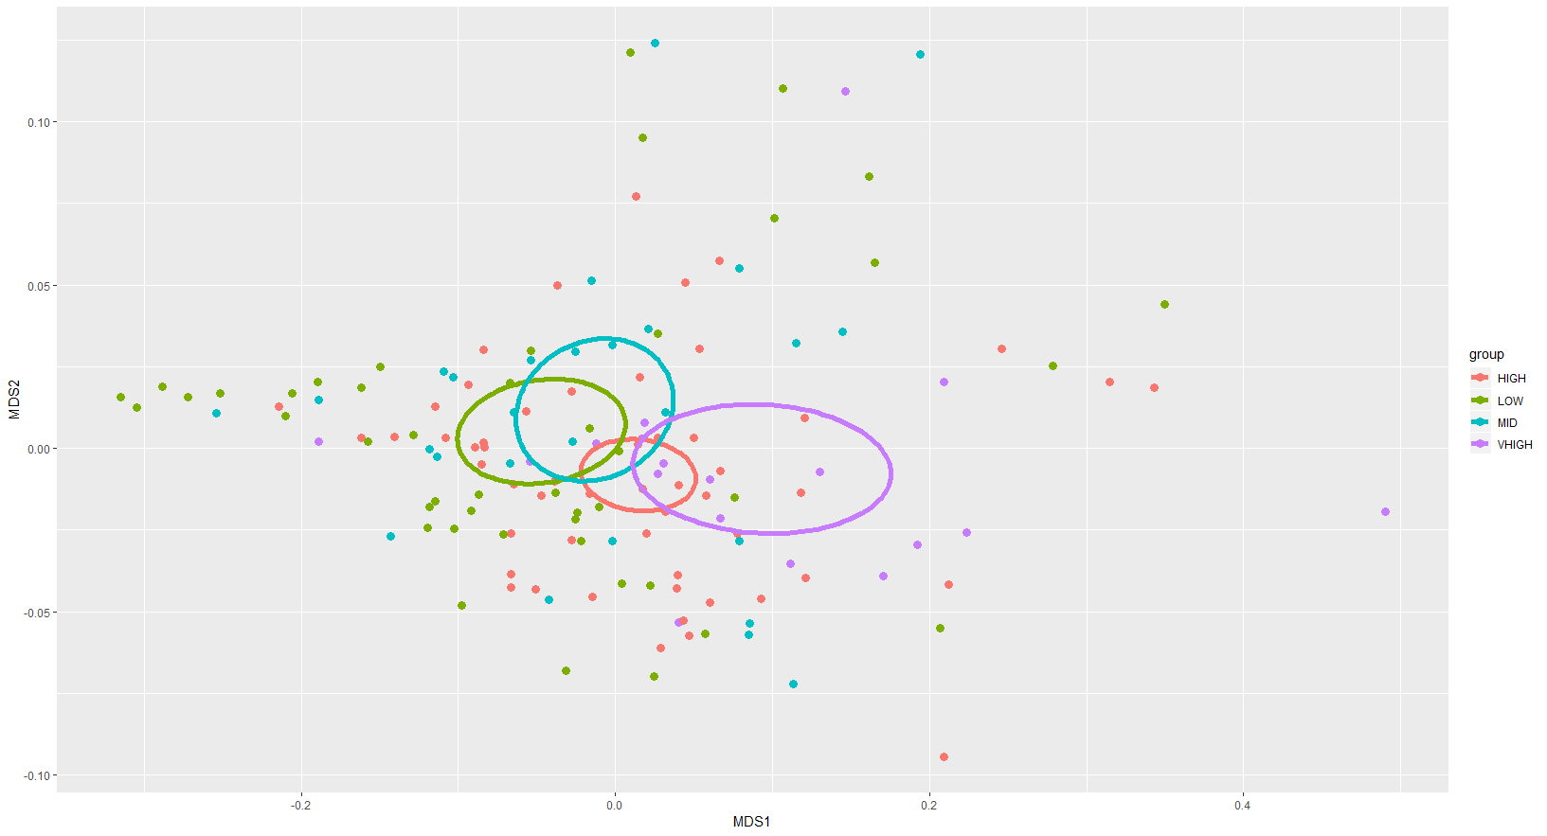

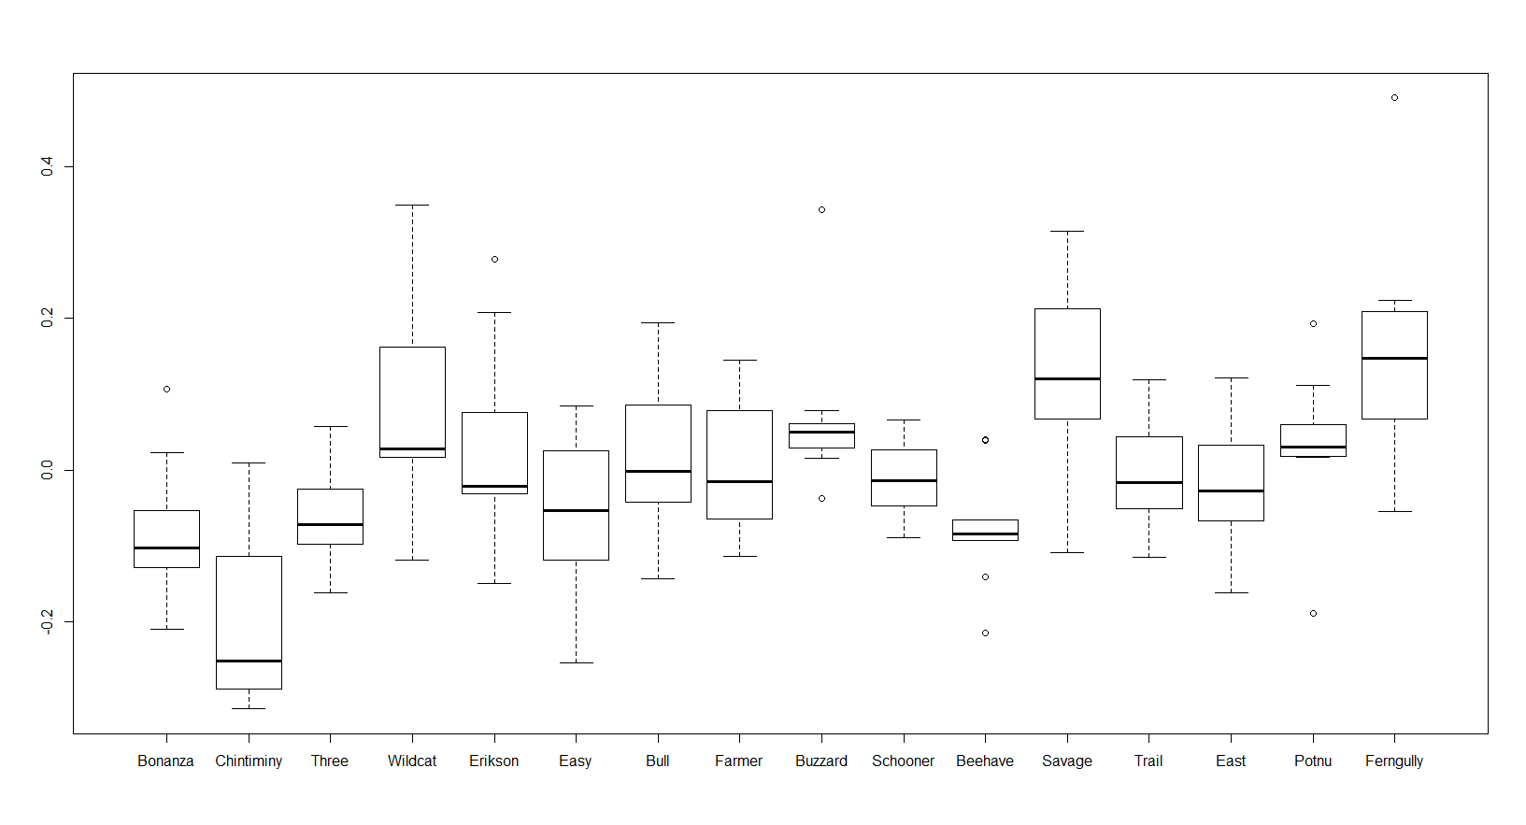

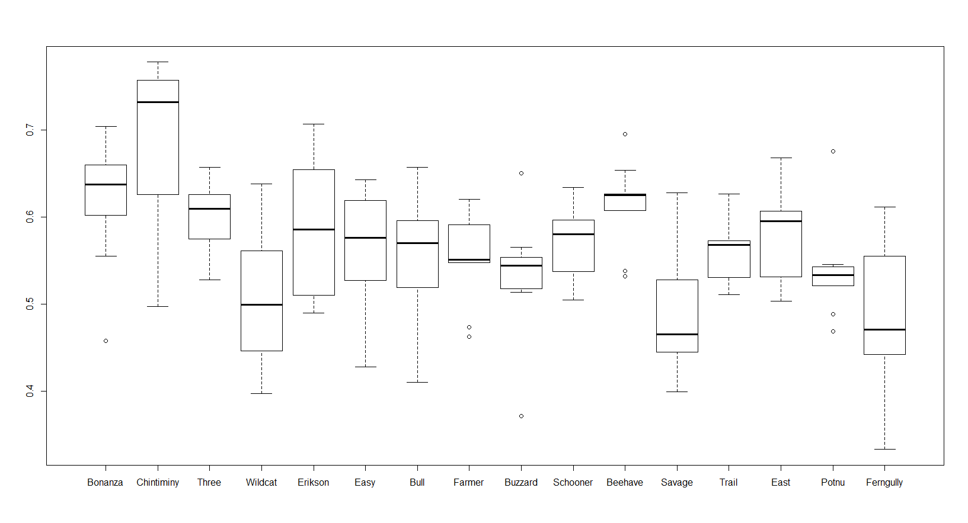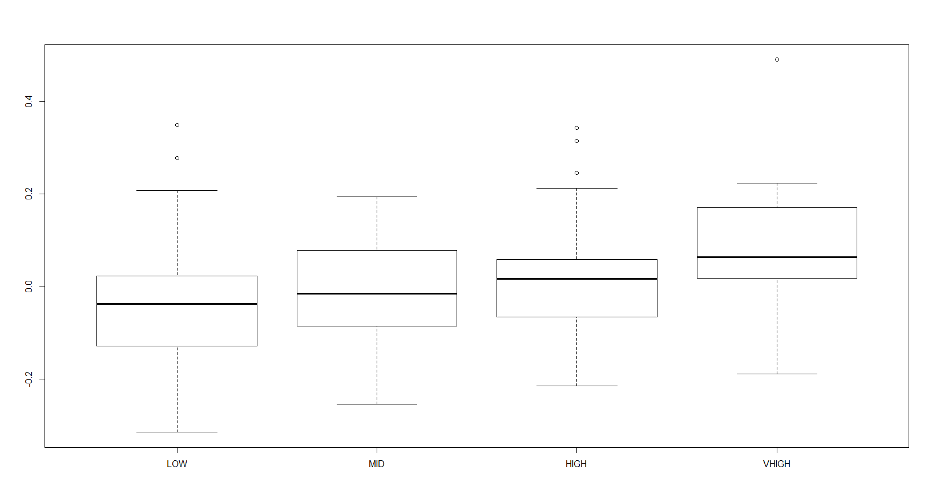

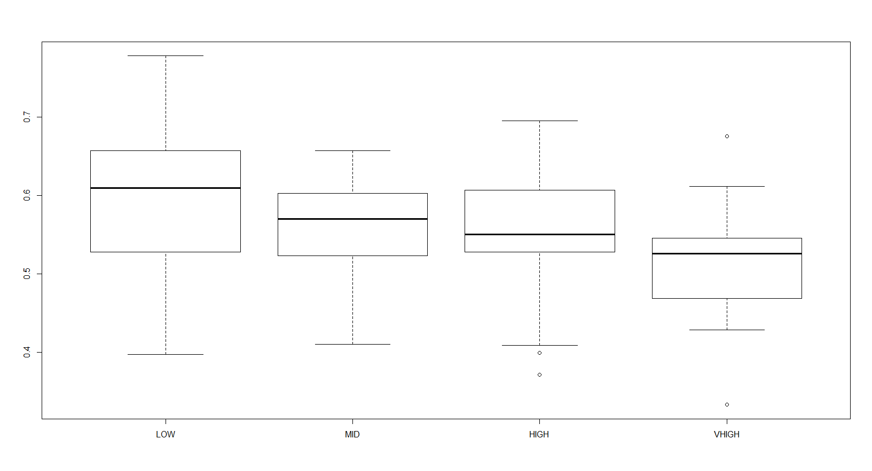

**DEPTH**

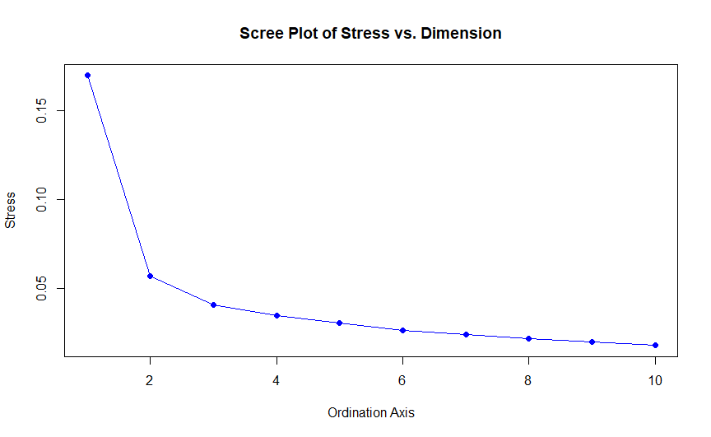

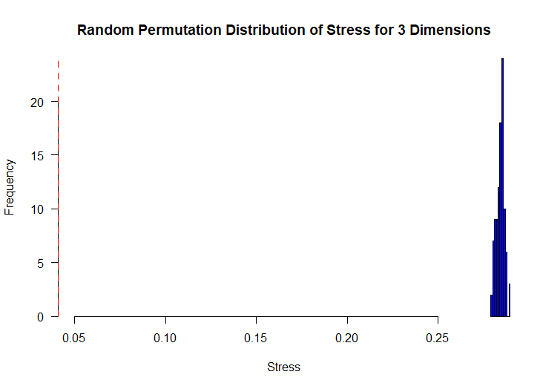

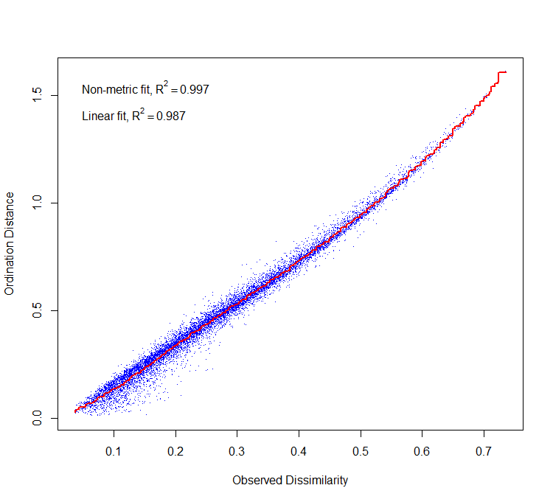 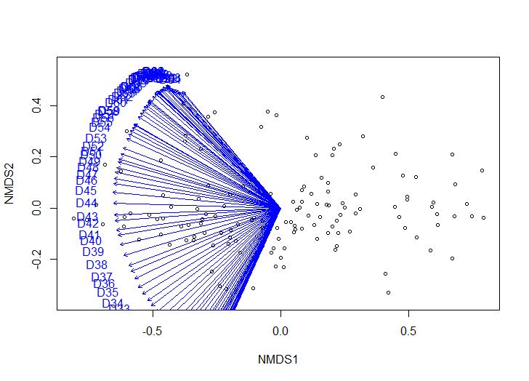 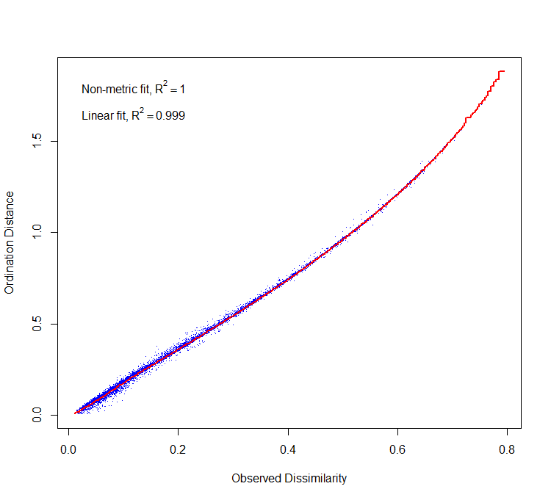

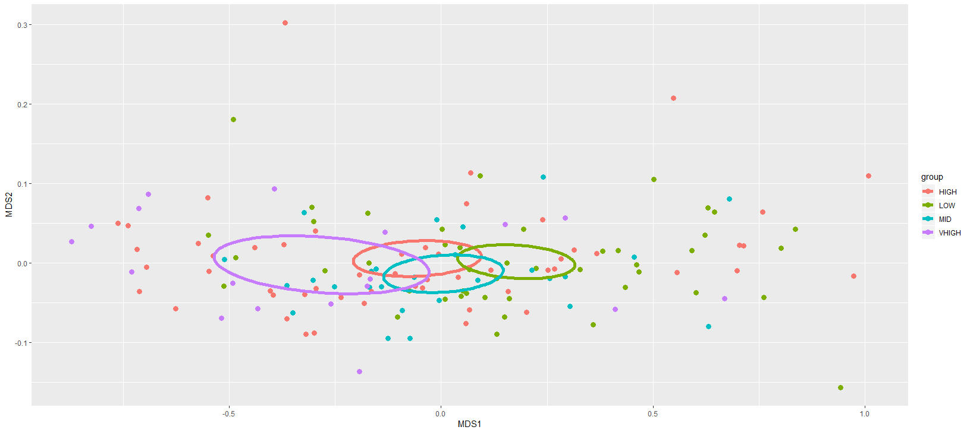

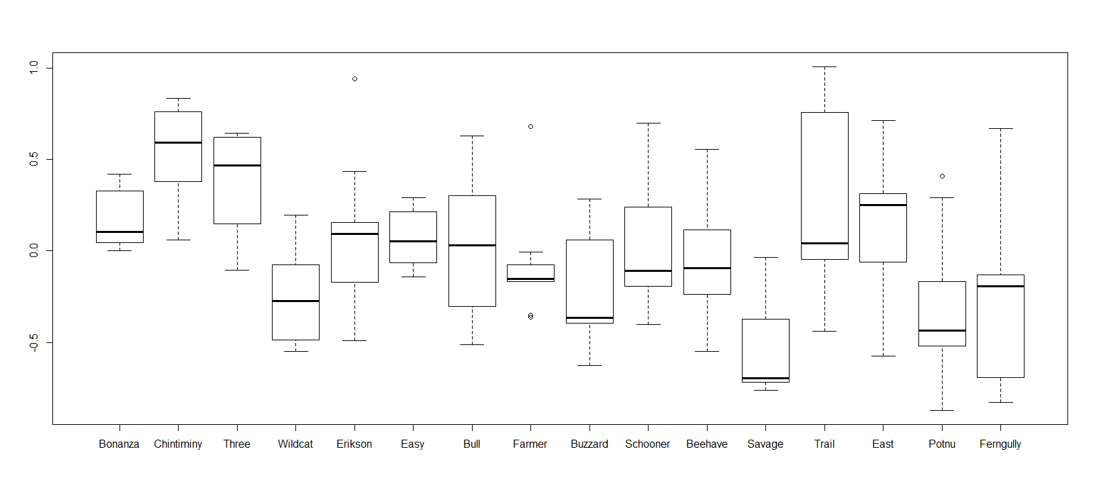 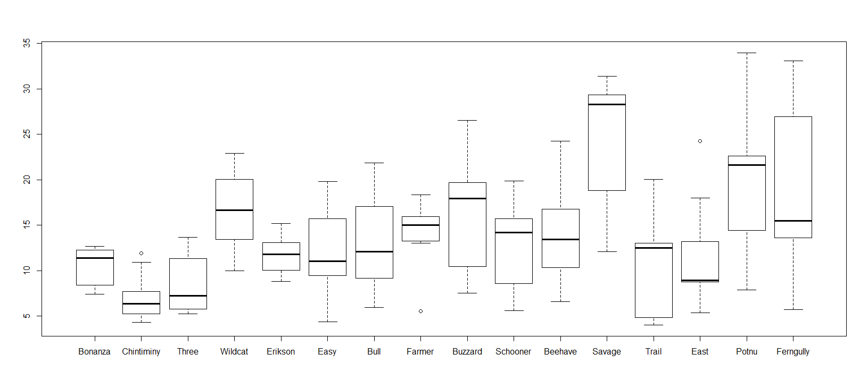

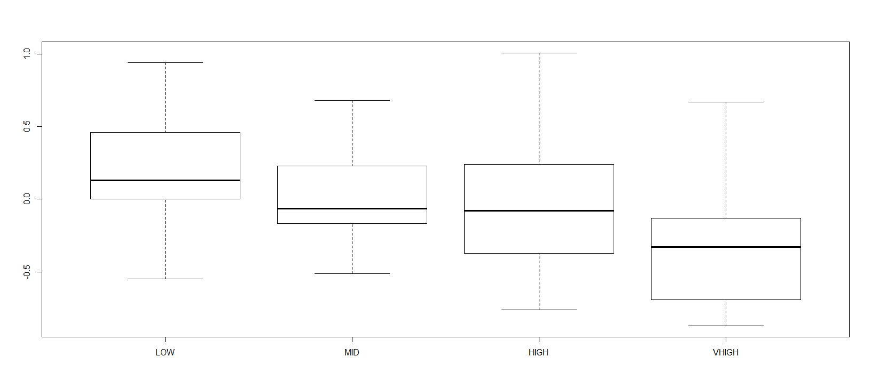 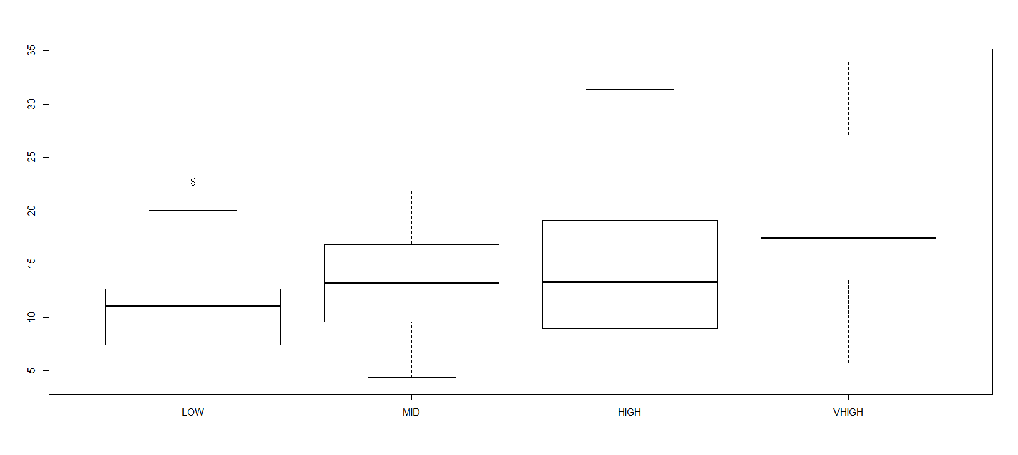

**Anosim analysis**

**Open**

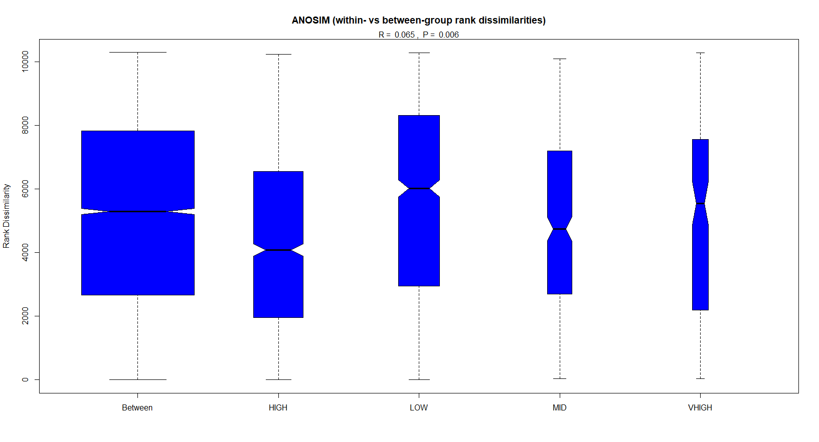

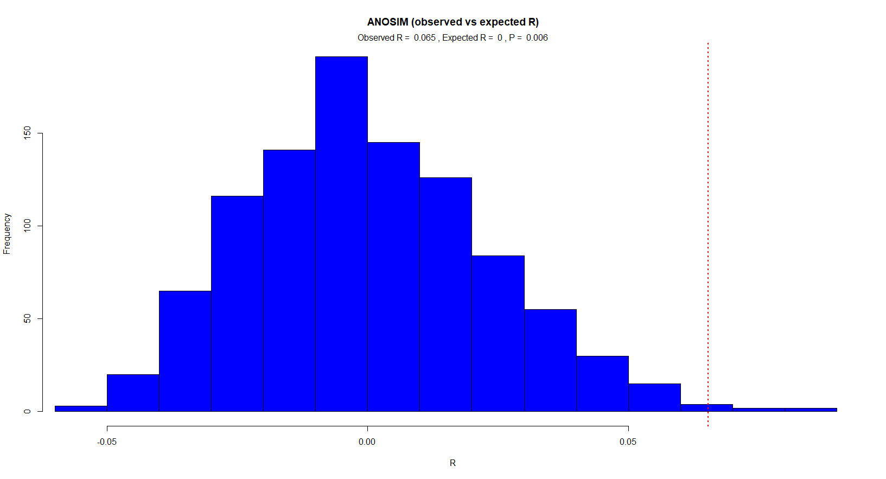

|  |  |  |  |
| --- | --- | --- | --- |
| ANOSIM R Statistic for Openness | | | |
| Overall 0.06535, P = 0.006** | | | |
|  | High | Mid | Low |
| Vhigh | 0.1129 | 0.09236* | 0.1236* |
| High |  | 0.033 | 0.07386** |
| Mid |  |  | -0.02183 |
|  | *p<0.05 | **p<0.01 |  |

**Depth**

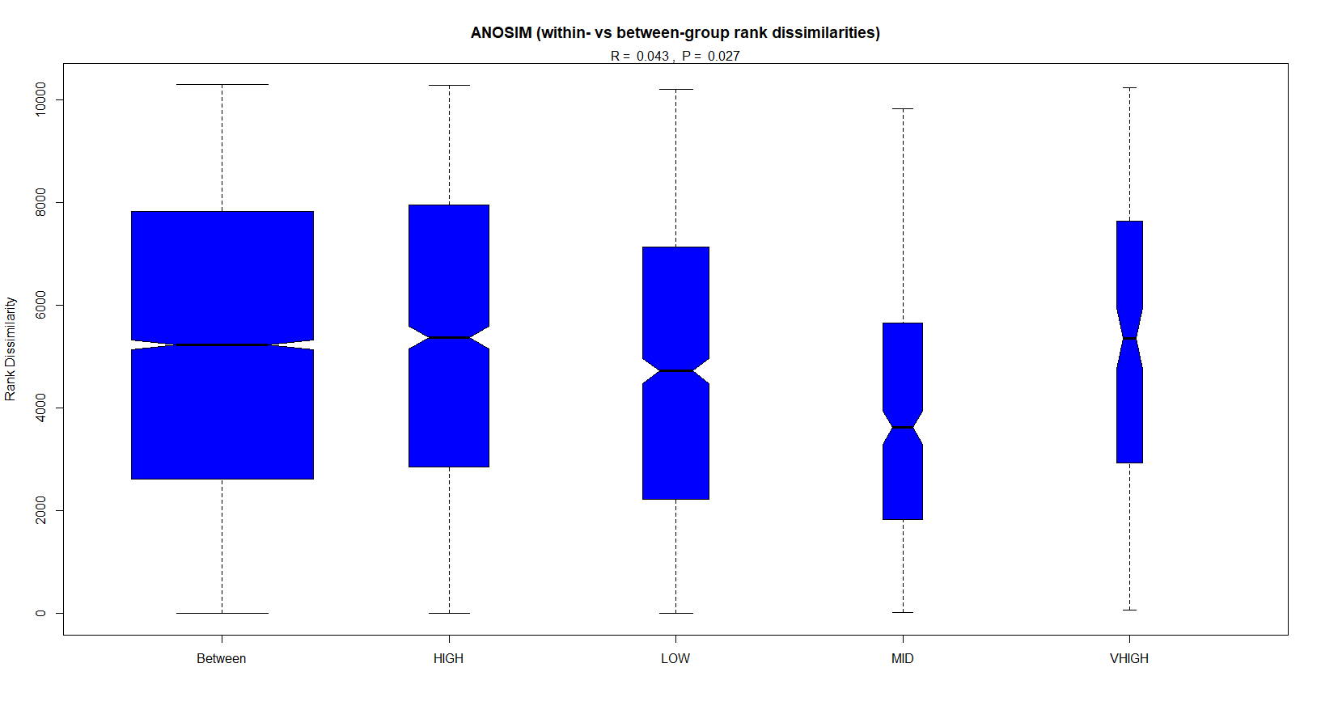

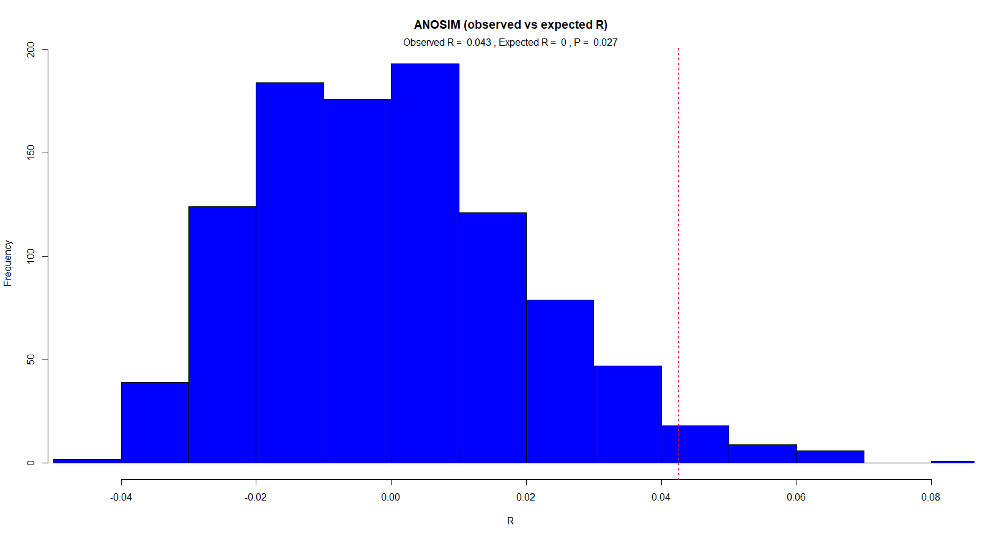

|  |  |  |  |
| --- | --- | --- | --- |
| ANOSIM R Statistic for Depth | | | |
| Overall 0.04253, P = 0.027* | | | |
|  | High | Mid | Low |
| Vhigh | 0.01441 | 0.1788** | 0.2413** |
| High |  | -0.0598 | 0.05388* |
| Mid |  |  | 0.006438 |
|  | *p<0.05 | **p<0.01 |  |